New Voluntary Mark Description in the International Application and Subsequent Designation Forms
and
Special Filing Processes

New Voluntary Mark Description in the International Application and Subsequent Designation Forms

Effective November 1, 2017, the International Bureau (IB) will allow applicants to submit a voluntary mark description in the international application and subsequent designation forms. See Rules 9(4)(b)(vi) and 24(3)(c)(i) of the Madrid Common Regulations.

Before this rule, applicants were permitted to provide only the mark description from the underlying basic application or registration. The rule change allows applicants to provide a mark description of their choosing in the international application or subsequent designation forms. Including this voluntary mark description makes it possible to avoid provisional refusals from jurisdictions that impose different mark description requirements from those of the office of origin.

The USPTO will continue to require applicants to include the mark description from the basic application or registration in their international applications. The voluntary mark description is a supplemental description that can be included in the international application or subsequent designation to avoid provisional refusals from designated countries that impose different mark description requirements from those of the USPTO.

You can find information about the filing requirements, including mark description requirements, of other Madrid Member States in the World Intellectual Property Office (WIPO) Madrid Member Profiles database.

Special Filing Processes

Until the USPTO’s electronic filing system has been updated to reflect the rule change, applicants who want to include a voluntary mark description in an electronically filed international application must follow a special filing process. Those who want to include a voluntary mark description in an electronic subsequent designation should file the request directly with the International Bureau. The paper filing process for international applications and subsequent designations at the USPTO remains the same. Read below for more information and detailed filing instructions.

Special Filing Process Required for Electronic Filing of the International Application

USPTO electronic Madrid forms cannot currently accommodate the voluntary mark description. If you want to include a voluntary mark description in your electronic application, you must follow the special filing process below.

- In the electronic international application form, select the free-text version of the form, found on the second screen:
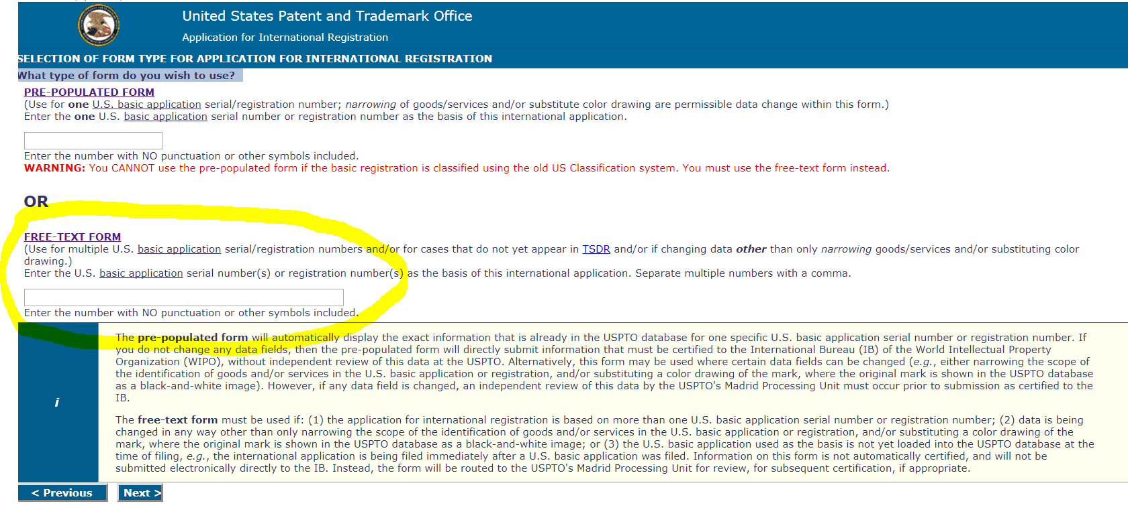
The free-text form will allow you to pay the USPTO certification fee and the international filing fees online. Note that the voluntary mark description cannot be entered in this form.
- Complete a PDF copy of the official WIPO international application form MM2, and enter the voluntary mark description in Section 9(e)(ii) of the form. The MM2 form and instructions can be downloaded from the WIPO forms page. You must use the official WIPO form, and you must complete the entire form. The USPTO will deny certification of the application if the form is incomplete or contains errors.
- As soon as possible, file an electronic Petition to the Director under Trademark Rule 2.146 using the serial number or registration number of your basic application or registration.
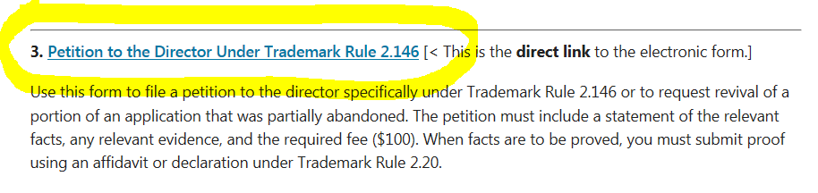
Attach the completed paper MM2 form to your petition form and explain in the text box that you are requesting replacement of the electronic international application with the attached digital copy of the MM2 form. You must include the USPTO reference number of the electronic application and the date on which it was filed in your petition form. You may also request that the petition fee be refunded because the petition is being filed to include the voluntary mark description in the international application.
It is important to file the petition immediately so that the request can be processed before the electronic international application is certified and transmitted to the IB.
- Immediately email the Madrid Processing Unit (mpu@uspto.gov) to notify them that you have filed a petition with a substitute MM2 form to have a voluntary mark description included in the application. Include the serial number or registration number of the basic application or registration that you used to file the petition and the USPTO reference number of the TEASi international application. This will ensure that the electronic international application will not be certified before the petition is processed.

Electronically Filed Subsequent Designations Must Be Filed with the International Bureau

USPTO electronic Madrid forms cannot currently accommodate the voluntary mark description in electronically filed subsequent designations. If you want to include a voluntary mark description in an electronically filed subsequent designation, you should file the electronic subsequent designation form directly with the IB. When you file a subsequent designation with the IB, you pay only the international filing fees. You are not charged the USPTO electronic subsequent designation transmittal fee of $100.

When an international registration contains a voluntary mark description, it will be automatically included in your subsequent designations. You can include a voluntary description in a subsequent designation only if one was not already included in the original international application.

A tutorial on filing a subsequent designation directly with WIPO can be found on WIPO’s E-Subsequent Designation filing page. Consult the WIPO Madrid System Fees and Payment page for information about fees and payment methods.

Paper Filing Process is Unchanged

The process for filing international applications and subsequent designations on paper remains the same. The WIPO paper international application form MM2 and paper subsequent designation form MM4 have been updated to accommodate the new voluntary mark description field. You must use the official WIPO forms on the WIPO forms page. See Madrid Tips for Paper Filers for more information about filing on paper.

For questions, please contact Debbie Lee at 571-272-8121 or Kelly Choe at 571-272-9429.

